Assignment 5 – Projects 4.12 & 5.8

I chose to continue the Pizza project from last week. I started by addressing the problems from your feedback, just followed the logic laid out in the instructions. Things seem to work properly, had to review the section on the copy constructor because my first attempt did not make a ‘deep copy’ like the text said. Appears to be working now, the pizza orders, 1 & 2, return different values.

I’ll be meeting with the tutor again this week for some pointers, and I look forward to your feedback. Thanks for the help!

**Screenshot of pizza class (1/2)**

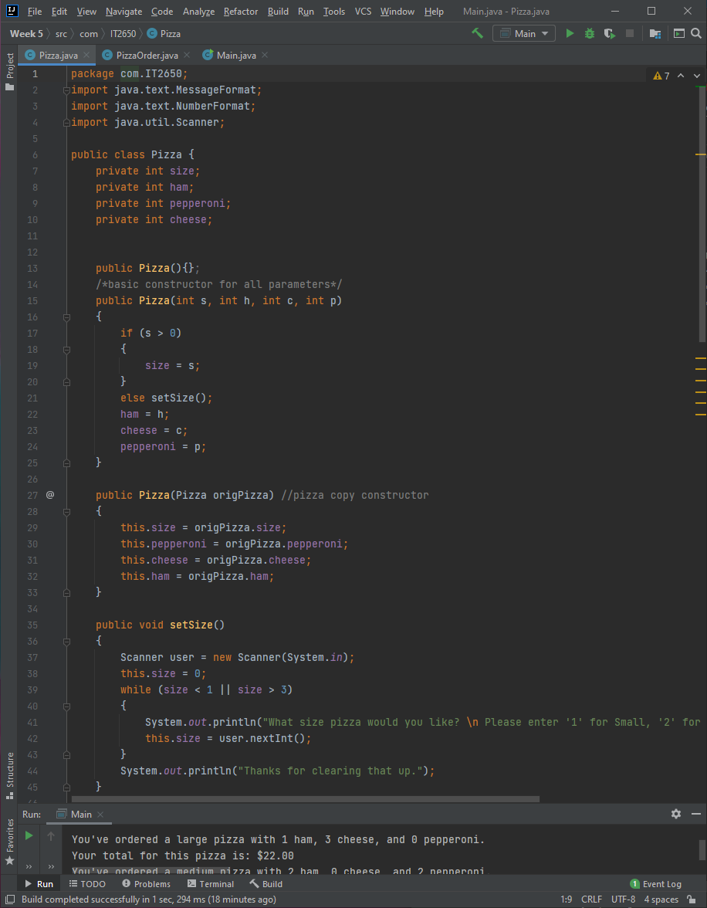

**Screenshot of pizza class (2/2)**

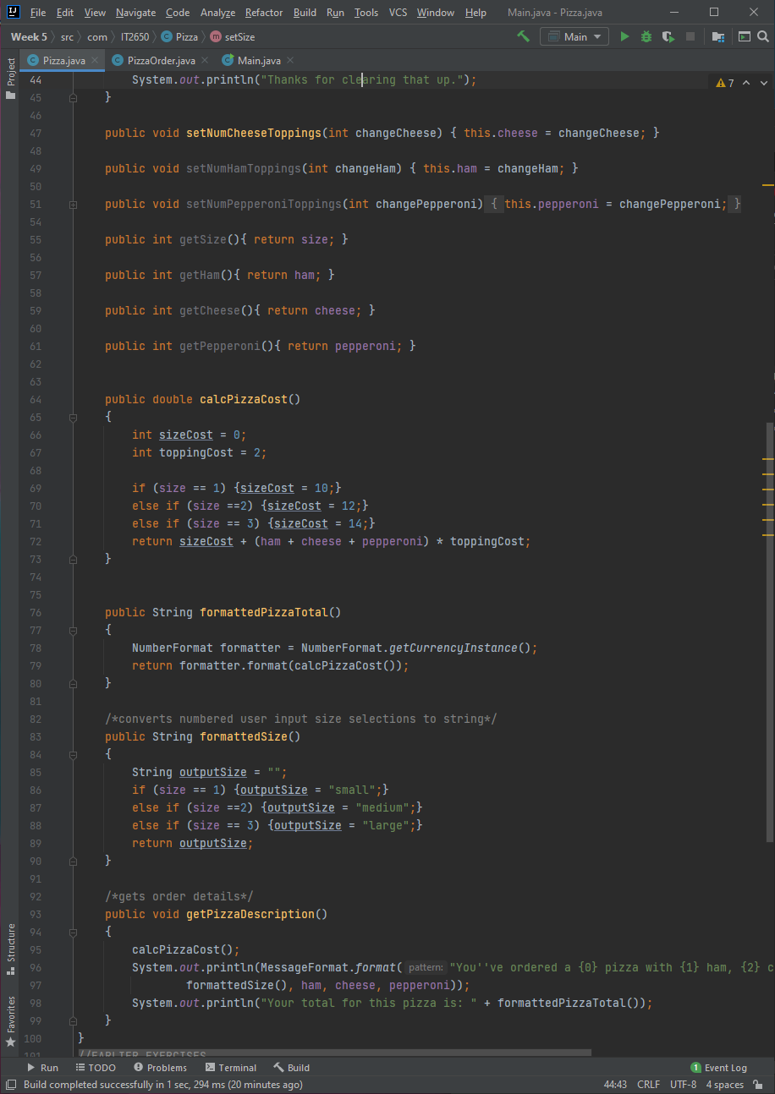

**Screenshot of PizzaOrder class (1/2)** 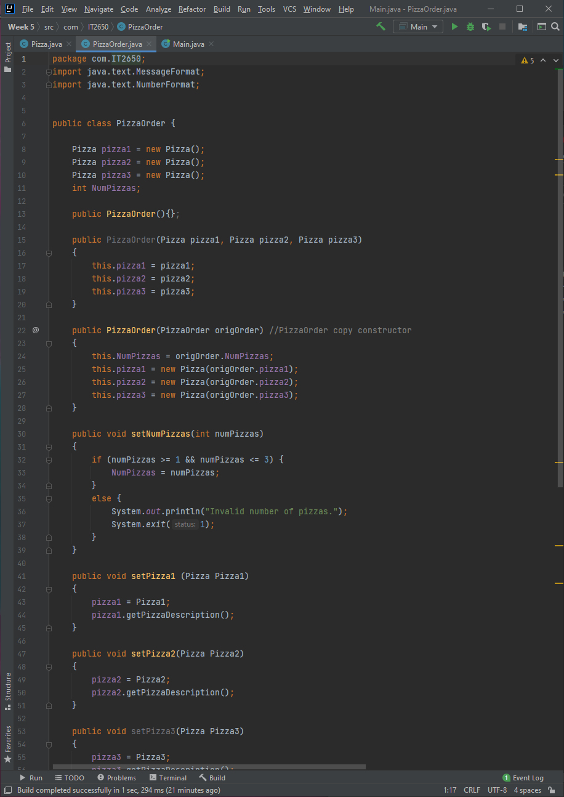

**Screenshot of PizzaOrder class (2/2)**

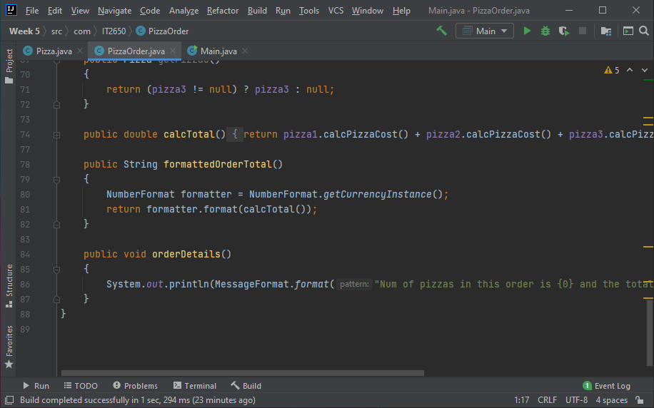

**Screenshot of Main.java**

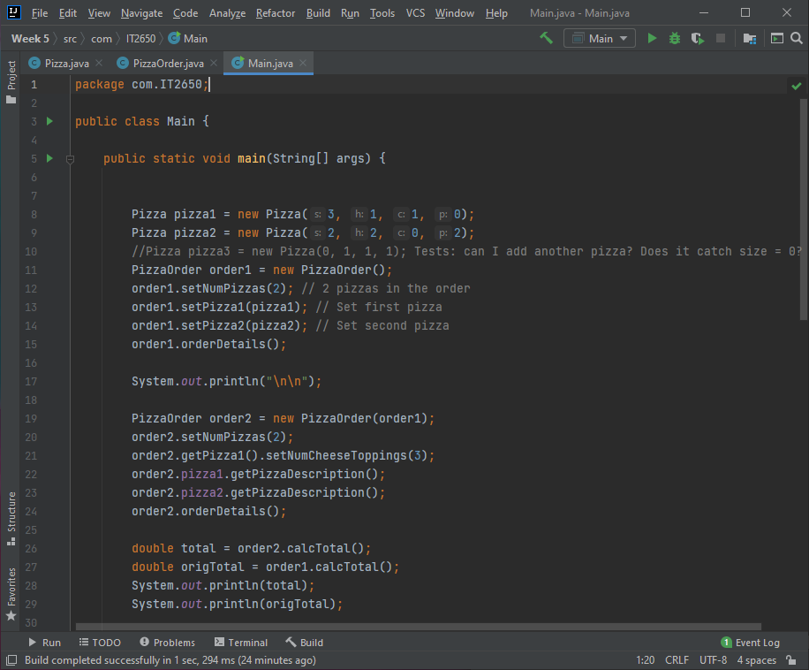

**Screenshot of program output**

